Ideation Phase
Empathize & Discover

Date | 25 September 2026
Team ID | 6ab4dd426603573ccfb5912f
Project Name | AI Blog Nest API
Maximum Marks | 4 Marks

Empathy Map Canvas:
An empathy map is a simple, easy-to-digest visual that captures knowledge about a user’s behaviours and attitudes.

It is a useful tool to helps teams better understand their users.
Creating an effective solution requires understanding the true problem and the person who is experiencing it. The exercise of creating the map helps participants consider things from the user’s perspective along with his or her goals and challenges.
AI Blog Nest API – Empathy Map:
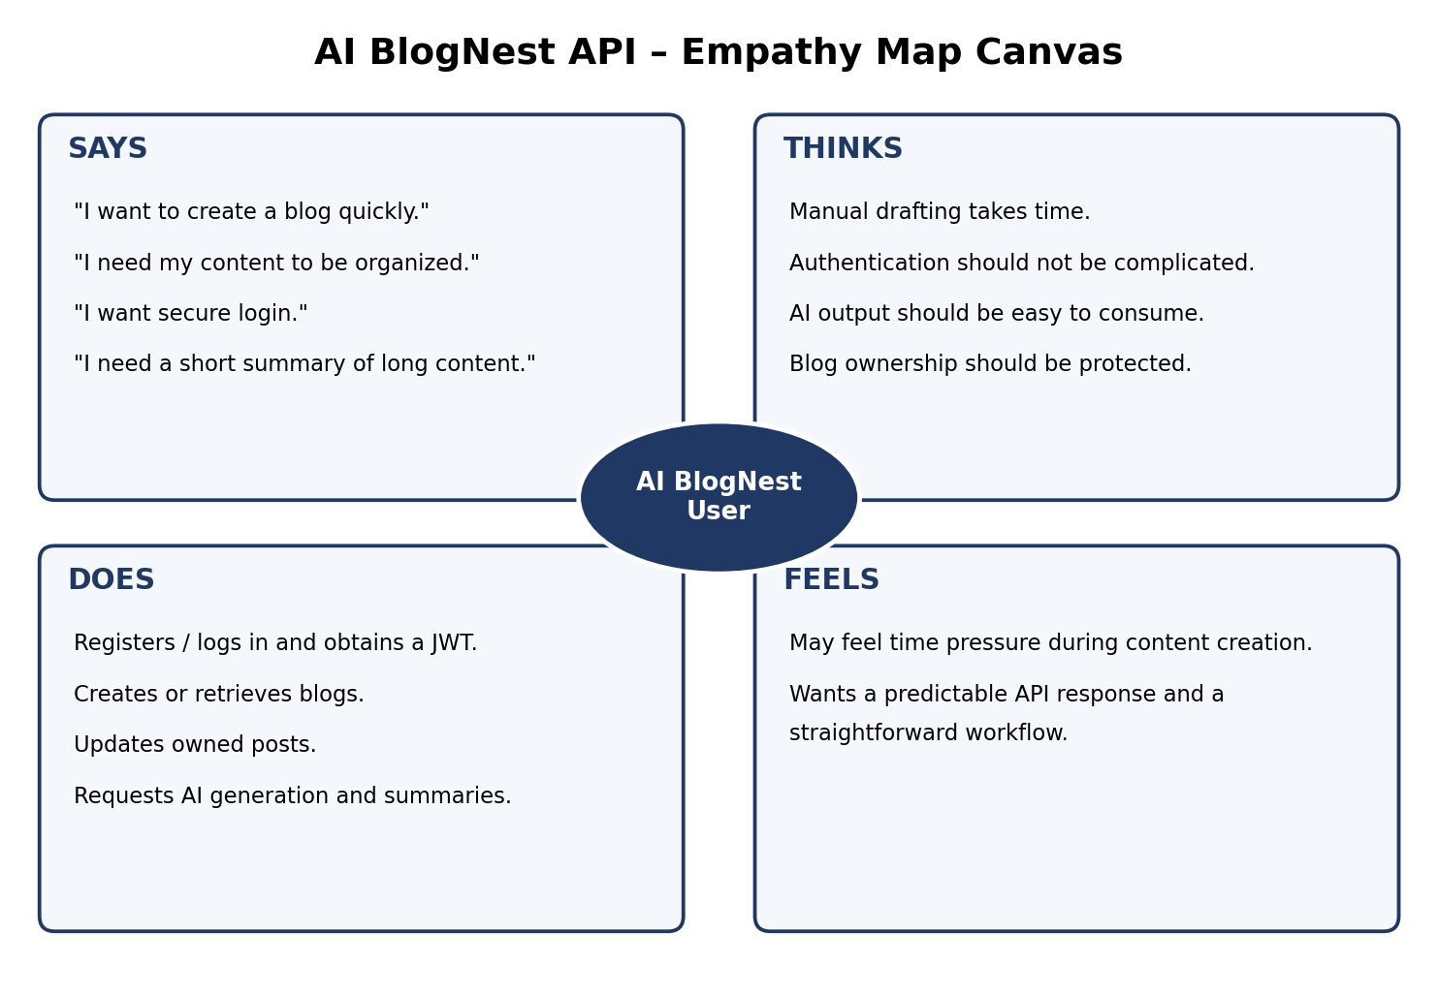
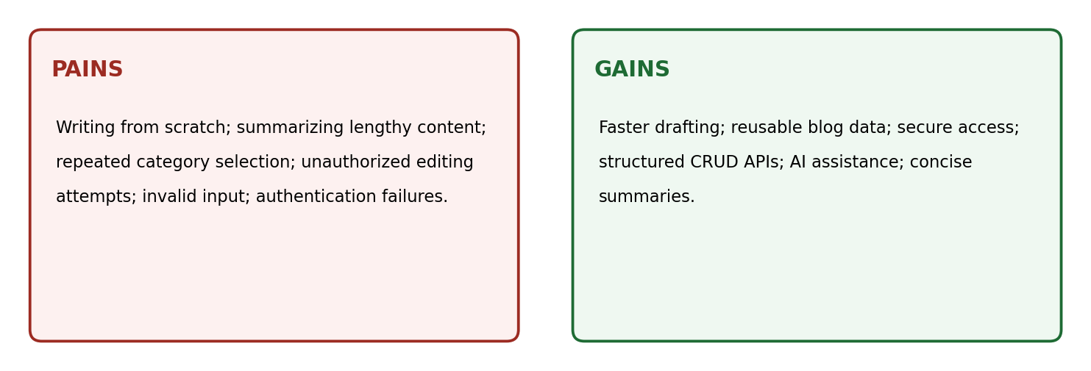

User Needs Identified – AI Blog Nest API:
S.No. | Need
1 | Fast content creation without removing user control over the final blog.
2 | Secure access to personal operations using JWT authentication.
3 | Clear validation feedback when required fields are missing or invalid.
4 | Simple access to blog content through standard REST endpoints.
5 | AI generation and summarization without requiring the user to integrate Gemini directly.
6 | Ownership checks so users cannot edit or delete another user's blog.

